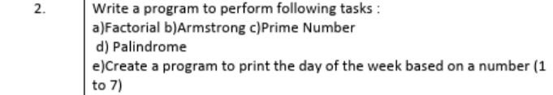
==============================================================================
Q.Write a program to perform following tasks :
a)Factorial
Program:
import java.util.*;
class Factorial
{
public static void main(String args[])
{
Scanner sc = new Scanner(System.in);
System.out.println("Enter a number: ");
int n = sc.nextInt();
long fact = 1; // factorial can be large, so use long
for(int i = 1; i <= n; i++) {
fact = fact * i;
}
System.out.println("Factorial of " + n + " is: " + fact);
}
}

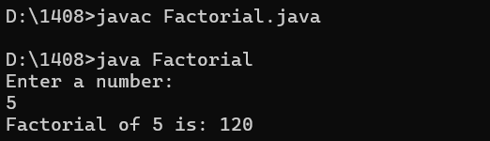

b)Armstrong
import java.util.Scanner;
class Armstrong
{
public static void main(String args[])
{
Scanner sc = new Scanner(System.in);
System.out.println("Enter a number: ");
int num = sc.nextInt();
int original = num;
int sum = 0;
while (num > 0) {
int digit = num % 10; // get last digit
sum += digit * digit * digit; // cube and add
num /= 10; // remove last digit
}
if (sum == original) {
System.out.println(original + " is an Armstrong number.");
}
else {
System.out.println(original + " is not an Armstrong number.");
}
}
}

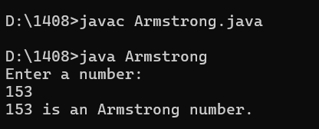

c)Prime Number
import java.util.*;
class Prime {
public static void main(String args[])
{
Scanner sc = new Scanner(System.in);
System.out.print("Enter a number: ");
int n = sc.nextInt();
int count = 0; // to count how many numbers divide n
for (int i = 1; i <= n; i++) {
if (n % i == 0)
{
count++;
}
}
if (count == 2) {
System.out.println(n + " is a Prime number.");
}
else {
System.out.println(n + " is not a Prime number.");
}
}
}

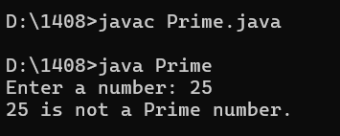

d) Palindrome
import java.util.*;
class Palindrome
{
public static void main(String args[]) {
Scanner sc = new Scanner(System.in);
System.out.print("Enter a number: ");
int num = sc.nextInt();
int original = num;
int rev = 0;
while (num > 0) {
int digit = num % 10; // get last digit
rev = rev * 10 + digit; // build reverse number
num = num / 10; // remove last digit
}
if (original == rev) {
System.out.println(original + " is a Palindrome.");
}
else {
System.out.println(original + " is not a Palindrome.");
}
}
}
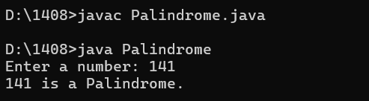

e)Create a program to print the day of the week based on a number (1 to 7)
import java.util.*;
class Day {
public static void main(String args[])
{
Scanner sc = new Scanner(System.in);
System.out.print("Enter a number (1-7): ");
int day = sc.nextInt();
switch (day) {
case 1: System.out.println("Monday"); break;
case 2: System.out.println("Tuesday"); break;
case 3: System.out.println("Wednesday"); break;
case 4: System.out.println("Thursday"); break;
case 5: System.out.println("Friday"); break;
case 6: System.out.println("Saturday"); break;
case 7: System.out.println("Sunday"); break;
default: System.out.println("Invalid number! Please enter 1 to 7.");
}
}
}

